* **style.css**

body {

background-image:linear-gradient(rgba(0,0,0,0.8),rgba(0,0,0,0.8)), url(libloginbg.jfif);

background-repeat: no-repeat;

background-size: 102% 900px;

font-family: Arial, Helvetica, sans-serif;

margin: 0;

}

.heading {

text-align: center;

text-decoration: none;

font-size: 45px;

style-height:100px;

height:65px;

width:100%;

}

.nav{

width:100%;

background-color:#333;

height:60px;

}

ul{

list-style:none;

padding:0;

margin:0;

position:absolute;

}

ul li{

float:left;

margin-top:10px;

}

ul li a{

width:auto;

color:white;

display:block;

text-decoration:none;

font-size:20px;

text-align:center;

padding:10px;

border-radius:10px;

font-family:Century Gothic;

font-weight:bold;

}

a:hover{

background:#669900;

}

ul li ul{

background:#333;

}

ul li ul li{

float:none;

}

ul li ul{

display:none;

}

ul li:hover ul{

display:block;

}

#but{

color: #FFFFFF;

}

#but1

{

color: white;

font-size: 18px;

}

.simple-form

{

text-align:center;

margin:10px 400px;

}

#registration

{

width: 100%;

background-color:#051019;

opacity: 0.8;

padding:50px 0px;

}

#butt

{

width: 200px;

padding: 10px;

border-radius: 5px;

outline: 0px;

background-color:#b53;

border: #01010c;

color: aliceblue;

font-size: 18px;

}

#button

{

padding:10px;

border-radius: 5px;

width: 290px;

outline: 0px;

}

#button1

{

padding:10px;

border-radius: 4px;

width: 100px;

outline: 0px;

}

#footer

{

margin-top:-2%;

margin-left:-1%;

margin-right:-1%;

margin-bottom:-2%;

background: #f00;

text-align: center;

color: #fff;

padding: 12px;

}

* **Library.html**

<!DOCTYPE html>

<html>

<head>

<title>Home</title>

<link rel="stylesheet" type="text/css" href="style.css">

</head>

<body>

<div class="heading">

<font color="#ffffff">Welcome Librarian</font>

</div>

<div class="nav">

<form name="libraryform" action="#" method="post">

<ul>

<li> <a href="Library.html">Home |</a> </li>

<li><a href="view.html">View Books|</a></li>

<li> <a href="search.html">Search Book |</a></li>

<li><a href="issue.html">Issue Book |</a></li>

<li><a href="return.html">Return Book |</a></li>

<li><a href="login.html">Log Out |</a></li>

</ul>

</form>

</div>

<p style="color: #88ebca; font-size: 110px; text-align: center;">Library Management System</p>

</body>

</html>

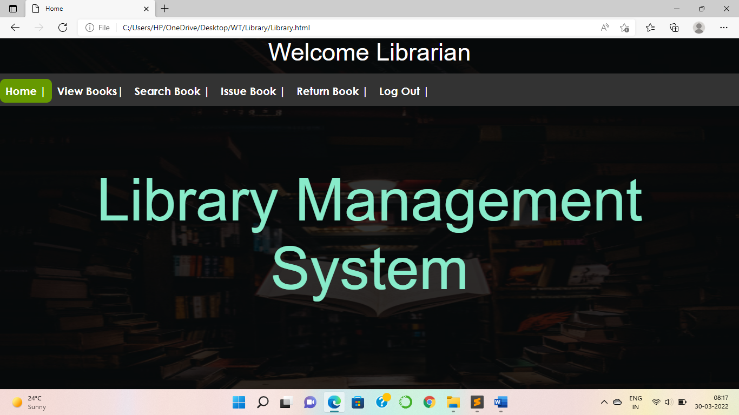

* **login.html**

<!DOCTYPE html>

<html>

<head>

<title>Login</title>

<link rel="stylesheet" type="text/css" href="style.css">

</head>

<body>

<div class="heading">

<font color="#00ff00">Library Management System</font>

</div>

<div class="nav">

<ul>

<li> <a href="Library.html">Login |</a> </li>

</ul>

</div>

<br/><br/>

<div class="title">

<br/><br/>

<h2>Login To Library</h2>

</div>

<div class="simple-form">

<form action="login.jsp" name="contact" method="post">

<br/><br/>

<fieldset id="registration">

<span id="but">Select role</span>&nbsp;&nbsp;<select id="button" name="role"><option value=1>Librarian</option></select><br><br>

<input type="text" name="fname" id="button" placeholder="Enter User ID" required><br/><br/>

<input type="password" name="pass" id="button" placeholder="Enter your Password" required><br/><br/>

<input type="submit" value="Login" id="butt">

<input type="reset" value="Reset Details" id="butt">

</fieldset><br/><br/><br/>

</form>

</div></br></br></br>

<!---------footer------->

<section id="footer">

<div class="container text-center">

<p><strong> @ MOHINI SHINDE | TECOC378</strong></p>

</div>

</section>

</body>

</html>

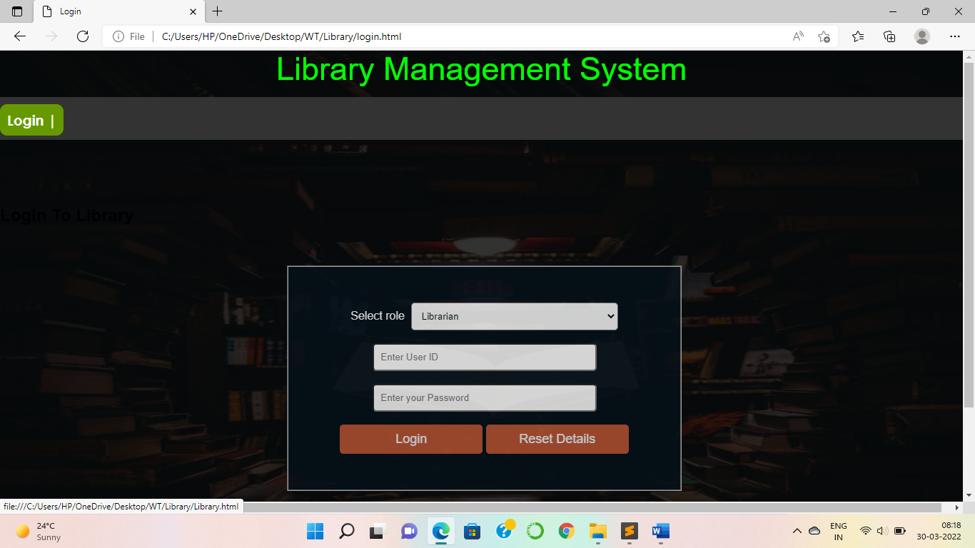

* **view.html**

<!DOCTYPE html>

<html>

<head>

<title>Login</title>

<link rel="stylesheet" type="text/css" href="style.css">

</head>

<body>

<div class="heading">

<font color="#00ff00">Library Management System</font>

</div>

<div class="nav">

<ul>

<li> <a href="Library.html">Login |</a> </li>

</ul>

</div>

<br/><br/>

<div class="title">

<br/><br/>

<h2>Login To Library</h2>

</div>

<div class="simple-form">

<form action="login.jsp" name="contact" method="post">

<br/><br/>

<fieldset id="registration">

<span id="but">Select role</span>&nbsp;&nbsp;<select id="button" name="role"><option value=1>Librarian</option></select><br><br>

<input type="text" name="fname" id="button" placeholder="Enter User ID" required><br/><br/>

<input type="password" name="pass" id="button" placeholder="Enter your Password" required><br/><br/>

<input type="submit" value="Login" id="butt">

<input type="reset" value="Reset Details" id="butt">

</fieldset><br/><br/><br/>

</form>

</div></br></br></br>

<!---------footer------->

<section id="footer">

<div class="container text-center">

<p><strong> @ MOHINI SHINDE | TECOC378</strong></p>

</div>

</section>

</body>

</html>

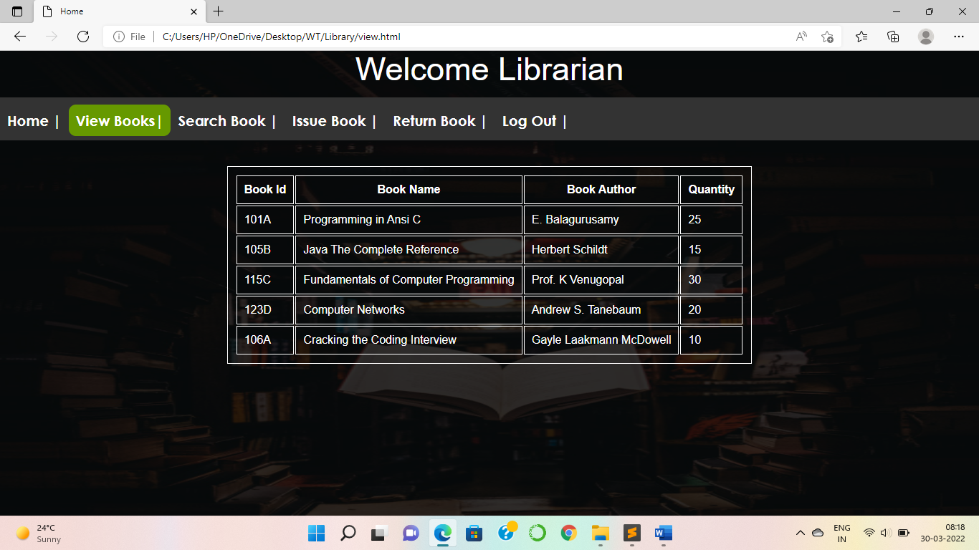

* **search.html**

<!DOCTYPE html>

<html>

<head>

<title>SEARCH BOOK</title>

<link rel="stylesheet" type="text/css" href="style.css">

</head>

<body>

<div class="heading">

<font color="#ffffff">Search Book</font>

</div>

<div class="nav">

<ul>

<li> <a href="Library.html">Home |</a> </li>

<li><a href="view.html">View Books|</a></li>

<li> <a href="#">Search Book |</a></li>

<li><a href="issue.html">Issue Book |</a></li>

<li><a href="return.html">Return Book |</a></li>

<li><a href="login.html">Log Out |</a></li>

</ul>

</div>

<div class="simple-form">

<form action="search.jsp" method="post" name="contact">

<fieldset id="registration">

<input type="text" name="bid" id="button" placeholder="Enter the Book ID" required><br/><br/>

<br/>

<input type="submit" id="button1" value="Search" required><br/><br/>

</fieldset><br/><br/><br/>

</form>

</div>

<br/><br/><br/><br/><br/><br/><br/><br/><br/>

<!---------footer------->

<section id="footer">

<div class="container text-center">

<p><strong> @ MOHINI SHINDE | TECOC378</strong></p>

</div>

</section>

</body>

</html>

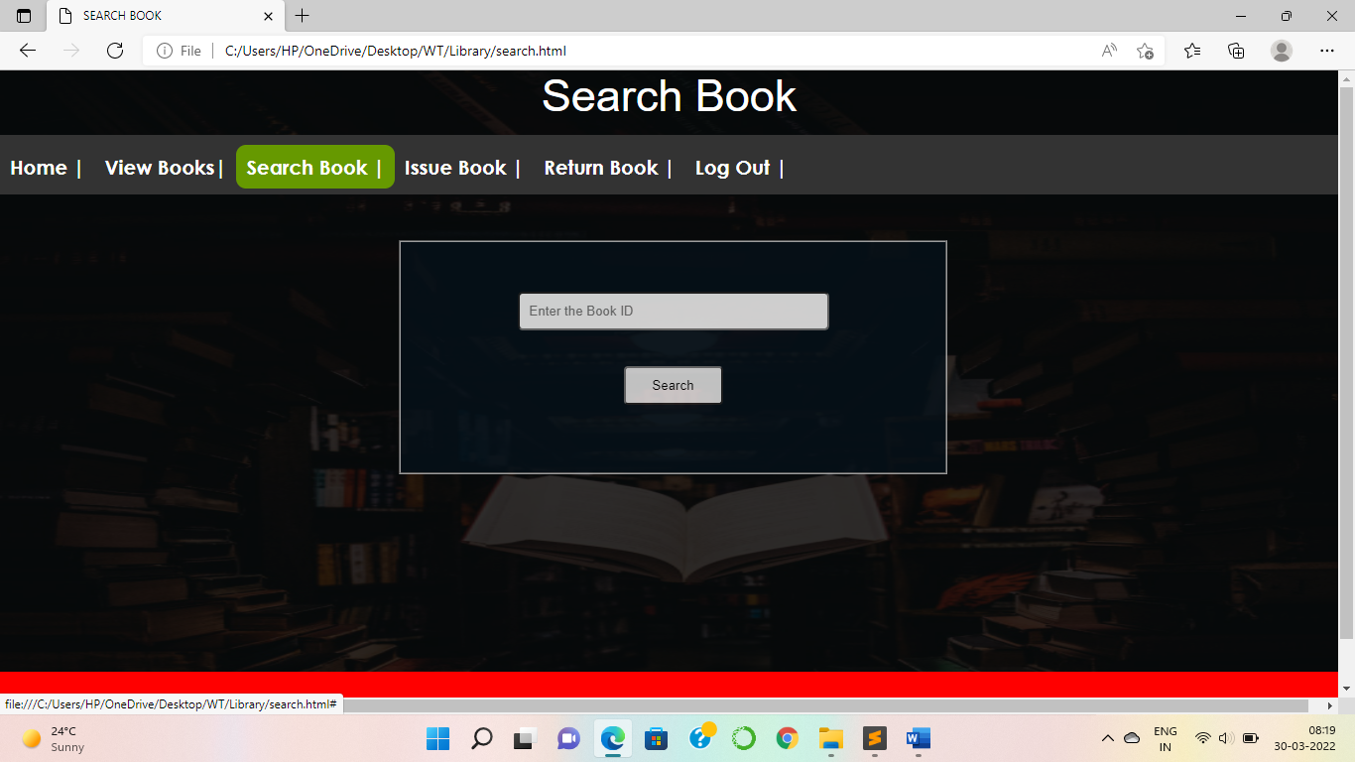

* **issue.html**

<!DOCTYPE html>

<html>

<head>

<title>ISSUE BOOK</title>

<link rel="stylesheet" type="text/css" href="style.css">

</head>

<body>

<div class="heading">

<font color="#ffffff">Issue Book</font>

</div>

<div class="nav">

<ul>

<li> <a href="Library.html">Home |</a> </li>

<li><a href="view.html">View Books|</a></li>

<li> <a href="search.html">Search Book |</a></li>

<li><a href="#">Issue Book |</a></li>

<li><a href="return.html">Return Book |</a></li>

<li><a href="login.html">Log Out |</a></li>

</ul>

</div>

<div class="simple-form">

<form action="issue.jsp" name="contact" method="post">

<fieldset id="registration">

<input type="text" name="bid" id="button" placeholder="Enter the Book ID" required><br/><br/>

<input type="text" name="bname" id="button" placeholder="Enter the Book Name" required><br/><br/>

<input type="text" name="aname" id="button" placeholder="Enter the Author Name" required><br/><br/>

<input type="text" name="sname" id="button" placeholder="Enter Student Name" required><br/><br/>

<input type="text" name="cname" id="button" placeholder="Enter Class" required><br/><br/>

<input type="text" name="rno" id="button" placeholder="Enter Roll No" required><br/><br/>

<input type="date" name="idate" id="button" placeholder="Enter Issue Date" required><br/><br/>

<input type="submit" value="Issue" id="butt">

</fieldset><br/><br/><br/>

</form>

</div>

<!---------footer------->

<section id="footer">

<div class="container text-center">

<p><strong> @ MOHINI SHINDE | TECOC378</strong></p>

</div>

</section>

</body>

</html>

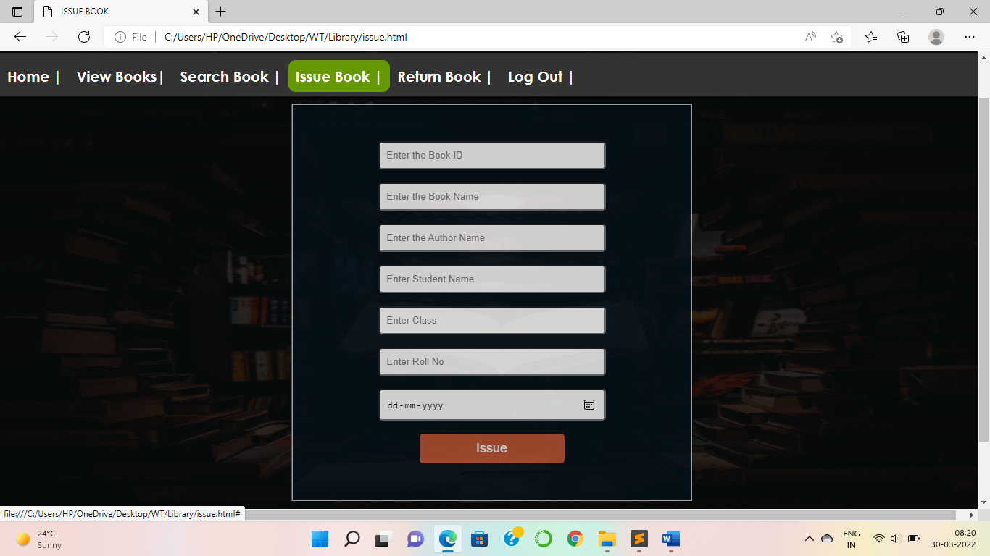

* **return.html**

<!DOCTYPE html>

<html>

<head>

<title>RETURN BOOK</title>

<link rel="stylesheet" type="text/css" href="style.css">

</head>

<body>

<div class="heading">

<font color="#ffffff">Return Book</font>

</div>

<div class="nav">

<ul>

<li> <a href="Library.html">Home |</a> </li>

<li><a href="view.html">View Books|</a></li>

<li> <a href="search.html">Search Book |</a></li>

<li><a href="issue.html">Issue Book |</a></li>

<li><a href="#">Return Book |</a></li>

<li><a href="login.html">Log Out |</a></li>

</ul>

</div>

<div class="simple-form">

<form action="return.jsp" name="contact" method="post">

<fieldset id="registration">

<input type="text" name="bid" id="button" placeholder="Enter the Book ID" required><br/><br/>

<input type="text" name="bname" id="button" placeholder="Enter the Book Name" required><br/><br/>

<input type="text" name="aname" id="button" placeholder="Enter the Author Name" required><br/><br/>

<input type="text" name="sname" id="button" placeholder="Enter Student Name" required><br/><br/>

<input type="text" name="cname" id="button" placeholder="Enter Class" required><br/><br/>

<input type="text" name="rno" id="button" placeholder="Enter Roll No" required><br/><br/>

<input type="date" name="rdate" id="button" placeholder="Enter Return Date" required><br/><br/>

<input type="submit" value="Receive" id="butt">

</fieldset><br/><br/><br/>

</form></div>

<br/><br/><br/>

<!---------footer------->

<section id="footer">

<div class="container text-center">

<p><strong> @ MOHINI SHINDE | TECOC378</strong></p>

</div>

</section></body>

</html>

